**Ideation Phase**

**Empathize & Discover**

|  |  |
| --- | --- |
| Date | 13 October 2023 |
| Team ID | PNT2022TMID593505 |
| Project Name | Project - AI System That Verifies User Identities Based On Their Online Behavior Patterns, Adding An Extra Layer Of Security. |
| Maximum Marks | 4 Marks |

**Empathy Map Canvas:**

An empathy map is a simple, easy-to-digest visual that captures knowledge about a user’s behaviours and attitudes.

It is a useful tool to helps teams better understand their users.

Creating an effective solution requires understanding the true problem and the person who is experiencing it. The exercise of creating the map helps participants consider things from the user’s perspective along with his or her goals and challenges.

**Example:**

Reference: <https://www.mural.co/templates/empathy-map-canvas>

**Example: AI System That Verifies User Identities Based On Their Online Behavior Patterns, Adding An Extra Layer Of Security.**

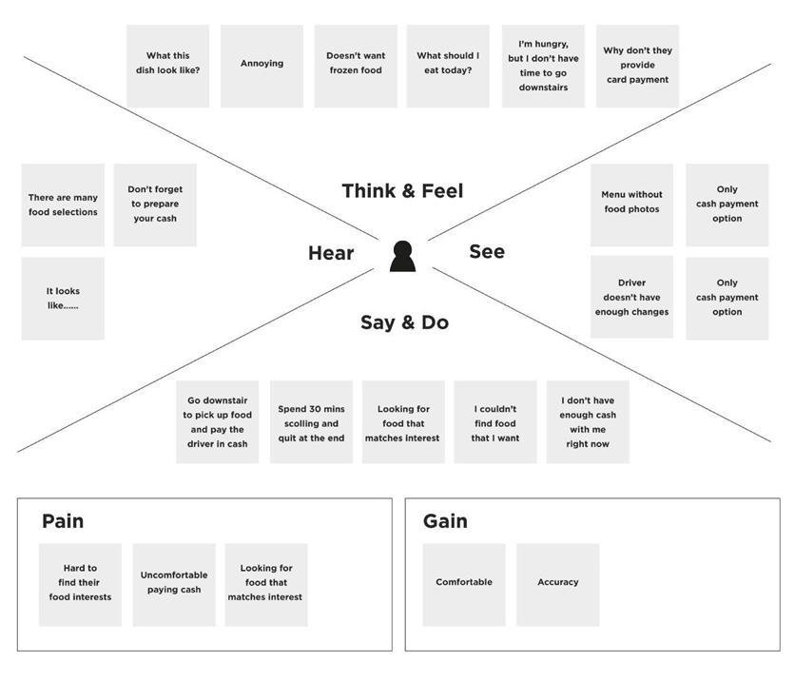

Reassurance

Efficiency

Convenience

Reduced control

Security Fears

Privacy concerns

Advocate for regulations to protect the privacy and security of users' online data.

This system is a great way to reduce fraud.

Enable the AI system on their accounts.

How does this system work?

There are so many online patterns

Don’t forget to hide your password

It is trending

Easy to understand and use

Constant adaptation

I don’t need to remember passwords anymore

I feel more secure

It feels unsafe to trust an AI

How is this different?